U11 Div 5
For all the Glory
Hockey Tournament
www.southwesthockey.com
November 25-27
Calgary, AB
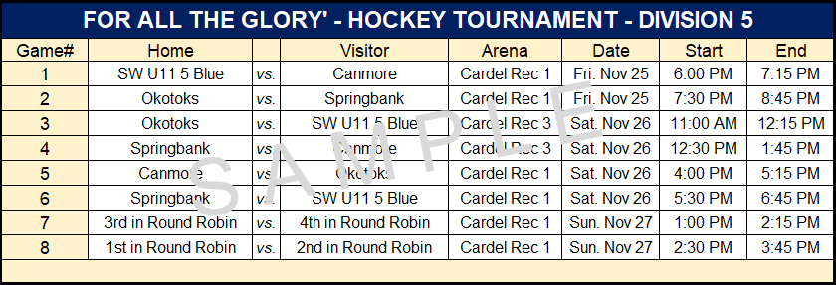

RULES
Pregame Warm-up is 3-minutes. Be ready!
PERIOD LENGTHS:
60-min. Permit: 13-13-13. 75-min. permit: 15-15-15
When there are 5-minutes remain on an ice permit, at the first stoppage of play the clock will be reset to 2-minutes and the remainder of the game will be completed with stop time.
TOURNAMENT FORMAT
4-team round robin. Tie games are permitted in the round - robin.
WIN = 2 PTS TIE = 1 PT LOSS = 0 PTS
STANDINGS & TIE-BREAKERS
Full Tie-Breaking formula will be posted beside the Tournament Board.
FINAL GAMES – TIE BREAKERS
Tie games in the Final Round will be posted at the Welcome Table.
We would like to thank the families of the SW U11 5 Blue team for their contribution to this tournament. A special thanks to our guests, tournament coordinators, volunteers, coaches, referees, managers and all others for making this tournament possible.

THANK-YOU

