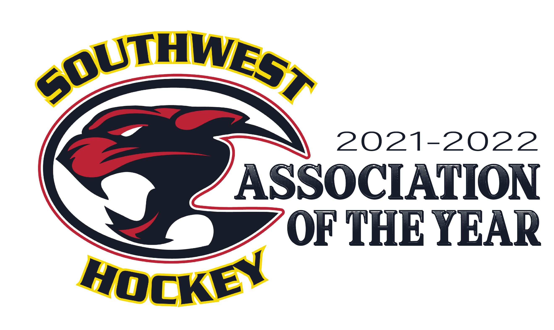

Coaching Philosophy and Team Rules

As Coaches of your child’s hockey team, we place fun and development of each child’s hockey skills at the top of our priorities. We expect the stronger players to help the weaker players elevate their play, though not at the expense of the stronger player’s development.

Hockey is a TEAM game! Which means the TEAM is only as strong as its weakest player. NOTE: ‘Weakest’ does not refer to the physical strength of a player, and rather overall attitude, effort, respect, and positivity.

We will endorse team play, good sportsmanship, along with both individual and team improvement. We MUST ALL RESPECT coaches, participants, parents, officials, and the facilities we play in, as well as their staff.

Our Governing Bodies Believe…

- In a positive hockey experience for ALL; in a safe, sportsmanlike environment.
- The development of life skills.
- The program of teamwork and the concept of team vs. individual.
- Fair Play, Sportsmanship and Respect.
- The development of dignity and self-esteem.
- The values of honesty and integrity.
- The values of hard work and determination.
- The benefits of personal and physical well-being.

Expectations

As a coaching staff, we will strive to adhere to our coaching philosophy, and the Fair Play Code at all times. We will strive to provide an enjoyable experience for all players regardless of skill level. Some players are content to just being an active participant; while others put pressure on themselves to win. It can be challenging to find the right balance, but that is our goal.

- We Expect BOTH Participants & Parents/Guardians to conduct themselves properly in and around the arena; and to abide by team rules, the Fair Play Code and to be supportive of all players and coaching staff.

- Online Communications/Chats: Policies are in place to deal with unacceptable behaviour, etiquette and conduct unbecoming by or towards participants, coaches, officials, parents/guardians & other volunteers. We expect BOTH participants and parents/guardians to have respectful communications. SW Hockey will hold its members to a ‘code of conduct’ that is responsible and refrains from unacceptable comments. Inappropriate behaviours will be dealt with on a case-by-case situation; that can include disciplinary action as deemed necessary.

Association Rules and Conduct

Having team rules regarding discipline is a necessary part of running any team. We will abide by the rules we are given from our governing bodies. One of the most important set of rules is the “Fair Play Code”. It is also best to discuss the topics of Sportsmanship, Commitment and team play BEFORE they become an issue.

Participants:

- Show respect for Teammates, Parents, Coaches, Officials and Opponents.
- Play Fair No intentional penalties or cheap shots will be tolerated.
- Put the TEAM first Praise your teammates; go for TEAM GOALS ahead of your own.
- Show Commitment to the team Take responsibility for what you contribute to games and practices; work hard during games AND practices.
- Give FULL attention to your coaches when they are speaking in the dressing room, on the bench during games and during practices.
- Be on time.
- Families must notify the Team Manager, & Head Coach with regards to all absences.
  - Minimum of 48 hours is a courteous expectation.
  - However, in the event of same day illness, injury or other unexpected cause – same day notice may be acceptable. Out of courtesy speak with the Head Coach/Assistant Coach in these situations.
- Offensive language will not be tolerated in the dressing room, on the bench or on the ice.
- Penalties are a part of the game, HOWEVER; excessive amounts of penalties, serious penalties that pose a safety risk or ongoing retaliatory penalties will NOT be tolerated

If any of the Team Rules are violated, there would be a meeting with the participant and parent(s)/guardian(s) to review the circumstances which would result in the following progressive consequences:

- 1st Offense Verbal Warning
- 2nd Offense Miss a Shift
- 3rd Offense Miss a Period
- 4th Offense Miss Two Periods
- 5th Offense Miss a Game

Depending on the severity of the situation, discretion is given to the Head Coach with regards to deviating from the above progressive consequences.

- ANY deviation from the progressive consequences noted within these team rules WILL BE discussed with the Director of Coaches and Assistant Director of Coaches; BEFORE the implementation of a more severe penalty.

Parent(s) / Guardian(s):

- Cheer for the TEAM, not just your favourite player.
- Be a TEAM-building block, not a stumbling block.
- Realize that TEAM rules are for everyone, all the time.
- Parents are only permitted in the dressing room; as per SW Hockey Policy and Procedure Section 26.0
- Use appropriate language (no profanity).
- Be supportive of coaches and officials. Conversations should be CALM and respectful.
- Show Respect for other participants and their parents/legal guardians.
- The ‘24 Hour Rule’ is ALWAYS in effect. Unless there is imminent danger.

Southwest Hockey has a strong stance against verbal and physical abuse of players, coaches, and officials. If anyone is not abiding by the rules, they will be asked to leave the rink. Further disciplinary action will be reviewed on a case-by-case basis.

By signing below; the participant, parent(s)/legal guardian(s) agree to abide by these team rules and accepts the consequences as outlined, if they should violate these team rules at any time during the 2022 – 2023 season.

Team: |  | (Example: U11 SW 4 Blue)

PLAYER NAME | PLAYER SIGNATURE | PARENT(S) NAME | PARENT(S) SIGNATURE

Coaching Staff
COACH NAME | COACH SIGNATURE | POSITION
 |  | HEAD COACH
 |  | ASSISTANT COACH
 |  | ASSISTANT COACH
 |  | ASSISTANT COACH
 |  | ASSISTANT COACH

SUBMIT THIS PAGE TO: ADMIN@SOUTHWESTHOCKEY.CA BY OCTOBER 30TH

